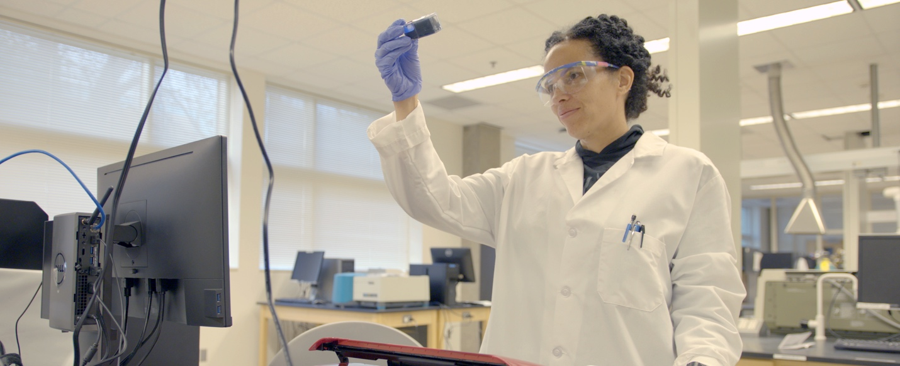

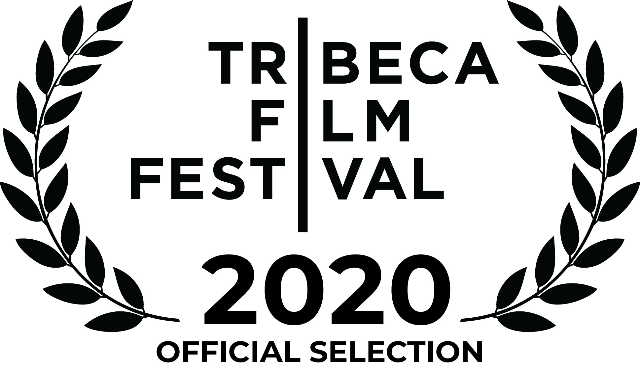
PICTURE A SCIENTIST
YEAR 2020 | RUN TIME 97 mins | LANGUAGE English
https://www.pictureascientist.com/
DIRECTED BY IAN CHENEY and SHARON SHATTUCK
PRODUCED BY MANETTE POTTLE, IAN CHENEY, and SHARON SHATTUCK

DISTRIBUTOR and SALES CONTACT:
Ro*co Films
Annie Roney
annie@rocofilms.com

PR CONTACTS:
Ian Cheney
iancheney@gmail.com
Sharon Shattuck
sharon.shattuck@gmail.com

TRAILER (embeddable):
https://vimeo.com/405966332

SYNOPSIS

PICTURE A SCIENTIST is a feature-length documentary film chronicling the groundswell of researchers who are writing a new chapter for women scientists. A biologist, a chemist and a geologist lead viewers on a journey deep into their own experiences in the sciences, overcoming brutal harassment, institutional discrimination, and years of subtle slights to revolutionize the culture of science. From cramped laboratories to spectacular field stations, we also encounter scientific luminaries who provide new perspectives on how to make science itself more diverse, equitable, and open to all.

FILMMAKING TEAM BIOGRAPHIES

IAN CHENEY
Director and Producer
Ian Cheney is an Emmy-nominated and Peabody Award-winning documentary filmmaker. He has completed nine feature documentaries, including King Corn (2007), The Greening of Southie (2008), The City Dark (2011), The Search for General Tso (2014), Bluespace (2015), The Most Unknown (2018), Picture Character (2019) and Thirteen Ways (2019). His films have premiered at film festivals and theaters worldwide and been released on Netflix, PBS, The Sundance Channel, VICE Media, and other networks. A former Macdowell fellow and Knight Science Journalism fellow at MIT, he lives in Maine.

SHARON SHATTUCK
Director and Producer
Sharon Shattuck is an Emmy-nominated documentary filmmaker and podcast host. From This Day Forward (2015), broadcast on POV (PBS) and was a New York Times Critic's Pick. She's the co-host of the podcast ‘Conviction: American Panic’ from Gimlet/Spotify, and the co-creator of the New York Times Op-Docs science series ‘Animated Life.' Her work has appeared on PBS, Netflix, National Geographic Channel, The New York Times, Vox, The Atlantic, Vice, ProPublica, Spotify, and Radiolab. She has degrees in forest ecology and journalism.

MANETTE POTTLE
Producer
Manette Pottle is a documentary filmmaker and producer whose interests focus on equity, bias, climate justice, faith, institutional change, and the intersections between science and personal and collective storytelling. She produced the film Behold the Earth (2017) about the evangelical environmental movement, as well as the Camden International Film Festival and its associated artists’ programs at the Points North Institute in Camden, Maine, and the Future of Science Film Fellowship, a program for emerging filmmakers to develop new documentaries about efforts to make science more equitable and inclusive. She received a B.A. in photography and critical theory from Yale University.

NATASHA BEDU
Editor
A graduate of the American Film Institute, Natasha Bedu served as lead editor on over a dozen episodes of A&E’s Emmy-winning series ‘Intervention,’ and was an editor on the popular Netflix series ‘Tidying Up with Marie Kondo.’ Her most recent project, a documentary series for the newly launched HBO MAX, follows the lives of LGBTQ history’s greatest heroes. Picture a Scientist is her latest feature film work, and she hopes to continue working on projects that explore themes of equality, justice, and the human struggle.

AMY BRAND
Executive Producer
Amy Brand is a leader in the field of scholarly communication and research information, and the current Director of the MIT Press. She is an associate at the Berkman Klein Center for Internet and Society, and serves on the boards of Crossref, Duraspace, Altmetric, and Board on Research Data and Information of the National Academies of Science, Engineering and Medicine.

FEATURED SCIENTISTS

Nancy Hopkins is a molecular biologist and professor of biology at the Massachusetts Institute of Technology. She is known for her research identifying the role genes play in longevity and cancer predisposition in adult fish, as well as for her work promoting equality of opportunity for women scientists in academia. She is a member of the National Academy of Sciences, the Institute of Medicine of the National Academy, and the American Academy of Arts and Sciences.

Raychelle Burks is a professor of analytical chemistry at St. Edward's University in Austin, Texas. Her research focuses on developing low-cost colorimetric sensors for detecting chemicals of forensic interest, including explosives and regulated drugs. As a science communicator, Burks has appeared on the Science Channel's Outrageous Acts of Science, the American Chemical Society’s Reactions videos, Royal Society of Chemistry podcasts, and at genre conventions such as DragonCon and GeekGirlCon. Burks was awarded the 2020 American Chemical Society Grady-Stack award for excellence in public engagement.

Jane Willenbring is a geomorphologist and professor of geology at the Scripps Institution of Oceanography, and director of the Scripps Cosmogenic Isotope Laboratory. Willenbring’s research examines the evolution of the Earth’s surface, especially how landscapes are affected by tectonics, climate change, and life on Earth. She is a 2018 Geological Society of America Fellow, and the recipient of the Antarctica Service Medal and the National Science Foundation CAREER Award.

ALSO FEATURING:

Paula Johnson
President, Wellesley College

Robert Brown
President, Boston University

Marcia McNutt
President, National Academy of Sciences

Mahzarin Banaji
Harvard University

Lotte Bailyn
Massachusetts Institute of Technology

Sylvia Ceyer
Massachusetts Institute of Technology

Penny Chisholm
Massachusetts Institute of Technology

Lorna Gibson
Massachusetts Institute of Technology

Ruth Lehmann
New York University School of Medicine

Terry Orr-Weaver
Massachusetts Institute of Technology

Mary-Lou Pardue
Massachusetts Institute of Technology

Molly Potter
Massachusetts Institute of Technology

Paola Rizzoli
Massachusetts Institute of Technology

Leigh Royden
Massachusetts Institute of Technology

Joanne Stubbe
Massachusetts Institute of Technology

Sangeeta Bhatia
Massachusetts Institute of Technology

Kathryn Clancy
University of Illinois

Adam Lewis
North Dakota State University (formerly)

Corinne Moss-Racusin
Skidmore College

Azeen Ghorayshi
Buzzfeed News

MAJOR FUNDERS

Heising-Simons Foundation
The Alfred P. Sloan Foundation
Sundance Institute Documentary Film Program with support from Sandbox Films
The New York State Council on the Arts
The Wonder Collaborative
Nancy Blachman

CREDITS

Executive Producer
Amy Brand

Directed by
Ian Cheney & Sharon Shattuck

Edited by
Natasha Bedu

Produced by
Manette Pottle
Ian Cheney
Sharon Shattuck

Co-produced by
Oluwaseun Babalola
Irene Yadao

Cinematography by
Emily Topper
Ian Cheney
Duy Linh Tu
Michael James Murray
Kelly West

Co-Editors
Nina Griffin
Ian Cheney
Jessica Potter

Consulting Editor
Jason Rosenfield

Original Score by
Martin Crane

Animation by
Midnight Snacks
Sharon Shattuck

Illustrations by
Sean McElroy
Anya Klepacki

Principal funding for this film provided by
Heising-Simons Foundation

Major funding for this film provided by
The Alfred P. Sloan Foundation

Additional Funding Provided by
Nancy Blachman
Anonymous
Sundance Institute Documentary Film Program with support from Sandbox Films
The New York State Council on the Arts
The Wonder Collaborative
The Educational Foundation of America
Chicken & Egg Pictures
Erica Brand and Adam Brand
The Benevity Community Impact Fund
Mar Hershenson
Kate Korsh
Jennifer Kane

Featuring
Jane Willenbring, Ph.D.
Lotte Bailyn, Ph.D.
Nancy Hopkins, Ph.D.
Raychelle Burks, Ph.D.
Victor Dzau, M.D.
Paula Johnson, M.PH., M.D.
Kathryn Clancy, Ph.D.
Sylvie Malhotra
Mary-Lou Pardue, Ph.D.
Sylvia Ceyer, Ph.D.
Molly Potter, Ph.D.
Ruth Lehmann, Ph.D.
Leigh Royden, Ph.D.
Penny Chisholm, Ph.D.
Marcia McNutt, Ph.D.
Paola Rizzoli, Ph.D.
Adam Lewis, Ph.D.
Sangeeta Bhatia, Ph.D.
Corinne Moss-Racusin, Ph.D.
Mahzarin Banaji, Ph.D.
Megan Reynosa
Azeen Ghorayshi, M.Sc.
Anonymous
Robert Brown, Ph.D.
Joanne Stubbe, Ph.D.
Lorna Gibson, Ph.D.
Terry Orr-Weaver, Ph.D.
Stephanie MacQuarrie, Ph.D.
Emma Harrison, Ph.D.
Travis Clow, M.S.

Sound Recordists
Judith Karp
Djim Reynolds
Justan Ross
Susan Bryant
Andrew Garrison

Archival Researcher
Kate Walker

Colorist
Alexander Berman

Post Production Wizard
Eugene Lehnert

Re-Recording Mixer
Eli Cohn

Dialogue Editors
Ben Chesneau
Maya Peart

FX Editor
Jack Sasner

Production Assistants
Dietrich Strause
Colin Cheney
Irene Yadao
Kristina Latino
Sadie Saltzman
Bita Ghassemi
Rachel Hohenfeld
Sharda Karim
D’Quan Rogers
David Brody
Colin Williams

Researchers
Claudia Geib
Rachel Swaby

Associate Producers
Margaux Sax
Samantha Woods

Additional Editing by
Daniel Quintanilla

Assistant Editors
Lucy Green
Halle Johns
Camille Gunderson

Additional Cinematography by
Taylor Gentry
Kevin Belli
Ben Pender-Cudlip
Dan Lovering
Naiti Gámez
Helki Frantzen
Austin de Besche
Amy Bench
Nathan Dappen
Julie Hotz
Lucy Martens
Brian Henderson
Taylor Krauss
Eduardo Mariota

Musicians
Tim Lappin, bass
Alba S. Torremocha, violin

Drone Operators
Michael James Murray
Nathan Dappen
Miguel Gutierrez

Advisors
Paula Apsell
Sangeeta Bhatia
Katy Chevigny
Elliot Kirschner
Laurie Santos
John Sylvanus Wilson

Legal Counsel
Donaldson & Callif LLP

Insurance
Allen Insurance

Mixed at
Nocturnal Sound

"Never One Thing"
Written by May Erlewine, Tyler Duncan
Performed by May Erlewine
Courtesy of Ghostly International LLC

Images of Radcliffe College courtesy of Schlesinger Library, Radcliffe Institute, Harvard University

Image of Radcliffe College courtesy of Patricia Hollander

“Nobel Prize for Men Probing Life’s Secrets” newspaper story courtesy of the Associated Press. Copyrighted 1962. 2142349:0320PF

Image of Francis Crick courtesy of Mark Lieberman and Creative Commons

Image of McMurdo Station courtesy of Reinhart Piuk and the National Science Foundation

Image of seven MIT professors courtesy of Rick Friedman

Flint, Michigan news clip courtesy of Democracy Now and Creative Commons

Youtube videos featuring Raychelle Burks courtesy of the American Chemical Society

Additional Images & Footage Courtesy of

Dreamstime • Alamy • Stockfresh • Pond5 • Camden Public Library • U.S. National Library of Medicine of the National Institutes of Health • Getty Images • Science Source • William J. Clinton Presidential Library • MIT Museum • San Francisco Chronicle • The New York Times • The Boston Globe • USA Today • The Associated Press • The Chronicle of Higher Education • The MIT Press • The Harvard Crimson • MIT Tech Talk • The Scientist • Nature • Lisa May • Michael Schwab • Golden Gate National Parks Conservancy • National Science Foundation • National Public Radio • ViacomCBS • Buzzfeed • NASA Armstrong Flight Research Center • NASA Kennedy Space Center • NASA Flickr • Canadian Society for Chemistry • House Committee on Science, Space, and Technology • NBCUniversal Media • WarnerMedia • Fred Rogers Productions • Mr. Wizard Studios • HBO • Nancy Hopkins • Raychelle Burks • Jane Willenbring • Adam Lewis • Allan Ashworth • Mary-Lou Pardue • Corinne Moss-Racusin

PICTURE A SCIENTIST is a fiscally sponsored project of Women Make Movies.

PICTURE A SCIENTIST is made possible by the New York State Council on the Arts
with the support of Governor Andrew M. Cuomo and the New York State Legislature.

With support from IFP

